 | Subject: |  |  | Report number:
 | Description of DAF EMS HIL Capabilities |  |  | --DRAFT--
 | Compiled by: | Department: |  | Telephone:
 | Niels de Grooth | PD-E-ES |  | 3634
 | Date: | Number of pages: | As seen: | Action/comments:
 | 9 May 2012

Description of DAF EMS HIL Capabilities

Contents
1 Introduction 4
1.1 Purpose of this document 4
1.2 Intended readership 4
1.3 Scope 4
1.4 Overview of this document 4
1.5 Terms, Definitions, abbreviations 5
2 HIL System overview 7
2.1 Simulation overview 9
2.2 Normal operation 10
2.2.1 Vehicle simulation 10
2.2.2 Test cell simulation 10
2.3 Influencing the model 10
3 ControlDesk 12
3.1 Overrides 12
3.2 Main layout 13
3.3 Operator 14
3.4 Cockpit 15
3.5 CAN Layouts 16
3.5.1 Engine CAN layout 17
3.5.2 After treatment CAN layout 18
3.5.3 Vehicle CAN 1 19
3.5.4 Vehicle CAN2 20
3.5.5 TSC1 messages 21
3.6 Running Man 22
4 DAFTA keywords for Manual Testing 23
4.1 …and Test automation 23
4.2 Work with DAFTA keywords 23
4.3 Live 24
4.4 KWP 25
4.5 Mechanic 28
4.6 Driver 28
4.7 XCP 29
4.7.1 Usage 29
4.7.2 Limitation 29
5 ATI Vision 31
5.1 Basics 31
5.2 Diagnostics 31
5.3 CAN & J1939 31
5.4 Flashing 31

Index

ATI Vision, 7
custom layout, 11
DTC, 23
keywords, 21
KWP, 23
layout, 11
Overrides, 11
PCI, 15
running man, 21
Rx, 15
StartKeywordsInControlDesk, 21, 22
Tx, 15

Introduction
Most of the testing by EMS is conducted using a HIL system. DAF EMS maintains its own HIL lab for that purpose.

Purpose of this document
This document describes the capabilities of the systems present in the HILLab in order to inform users and test designers. This should enable them to carry out and design tests that can be executed in a straight forward manner in the DAF EMS HILLab.

Intended readership
Software Tester
Function Owners
Software Engineer
Test Designer | To design tests suitable for execution

Scope
This document describes the main tools for software testing on an EMS HIL system.
These tools are:
- Simulation (HIL system + ControlDesk)
- ECU Monitoring software (ATI Vision)
With relation to the simulation, this document describes the connections between ECU and Simulation, as well as the relevant internal signals of the simulation. The relation of these in the simulation will be explained, so not every signal has to be described individually.
In relation to ECU Monitoring, the possibilities of ATI Vision will be summed up. More detail can be found in the manual.

The internal workings of ECU’s are not part of this document.

Overview of this document
This document starts with an overview of components of a typical HIL system and their relations in the EMS testing environment. Chapter 3 goes deeper into the available controls in the simulation. Chapter 4 tells about the possibilities of ATI Vision and how it can be utilized in ECU software testing.

Terms, Definitions, abbreviations

Terms | Description
A2L item | Generic term for variables and parameters in the ECU software
Hypertac | Short for Hypertac connector, the connectors that attach an ECU harnass to the HIL system
HIL system | Simulation system consisting of Computing unit, IO unit that runs a simulation model and simulates all signals to be interfacing with the SUT
Software label | See A2L item

Definition | Description
ATI Vision | Software to monitor variables and change parameters online in the ECU software
ControlDesk | Software to monitor variables and change parameters online in the simulation.
Operation Point | Point in RPM, Torque space for a running engine.
Tx | Transmission from the ECU
Rx | Reception by the ECU
Abbreviation | Description
BoB | Break out Box
DAFTA | DAF Test Automation framework
ECU | Electronic Control Unit
FIU | Failure insertion Unit
HIL | Hardware in the loop:  “Hardware” refers to the ECU hardware.  The “loop” is the control loop of plant (Simulation) and controller (ECU).
PCI | Paccar Controller Injection
SUT | System under test

HIL System overview
The HIL system is designed for the purpose of testing the software inside the engine ECU. The simulator provides signals to the engine ECU in such a way that the ECU cannot see the difference between a real engine with real sensors and this simulator.
Figure 1: Principal components of ECU software testing on a HIL system.
The four essential components of software testing on a HIL system as shown in Figure 1 are:
- The system under test (SUT) : the ECU (Bottom Left)
- ATI Vision, to monitor variables and manipulate parameters in the program running on the ECU.
(Top Left)
- A simulation system, also referred to as HIL system that provides all signals to the ECU (Bottom Right)
- ControlDesk, to monitor variables and manipulate parameters in the simulation running on the HIL system. (Top Right)
The goal of the simulation is to keep the ECU ‘happy’. This means that model is just good enough to make sure that the diagnostics of the ECU do not trigger any fault. To achieve this, all interfaces that the ECU expects, must be present and represent sensible figures. Therefore a simulation is needed to provide virtual engine sensors with signals that relate to each other and time as if a real engine is present. The next paragraph will give an overview of the simulation.

Simulation overview
To understand how the visualization of the simulation is built up, is good to know how the simulation is built up. At the top level of the simulation model, shown in Figure 2, the simulation consists of 3 types of subsystems:
- White: the actual physical simulation and other calculations
- Light blue: interfaces to controldesk with overrides
- Green: These blocks contain the connections to the outside world.
Interface of Physical simulation blocks
Physical simulation blocks
Figure 2: Top level of simulation model in Simulink
From a simulation point of view, the green blocks can be seen as the controller. Since these blocks actually form the interface to the dSpace hardware they are not relevant for testers.
Three white blocks contain the actual physical simulations and/or conversions. In the model overview it can be seen that, after every (white) simulation block, there is a (blue) interface block. This way it is possible to read the relevant outputs of simulation blocks in ControlDesk and for testing purposes it is possible to provide the rest of the model with false information.
There are 3 main physical simulation blocks: Engine, Driveline + Vehicle, After treatment. The other white blocks contain conversions. Finally, the operator block is a mix of conversions and simulation with Cab controls, test cell model and gear automation. The operator block is the only block that is effectively put in parallel with its interface block.

Normal operation
Normal operation is running the engine without applying overrides. The HILLab simulation in the first place simulates all interfaces as if the ECU is mounted in a vehicle. In addition to that, it is also possible to run the engine like in a test cell. So, there are two ways to run the engine:
- In a vehicle
- In an engine test cell
The HIL simulation model provides both modes. In any case, to run the engine, battery power must be present, the key on and the engine must be started.

Vehicle simulation
To perform the simulation for a vehicle, all driver controls that have a link with the engine are present in the simulation. For example, the tester can control acceleration pedal, brake pedal, cruise controls, gears and parking brake. The simulation takes care of the right signals to be sent to the ECU.
For general vehicle testing a tester can use these layouts
- MX_EU06.lay
- Cockpit.Lay

Test cell simulation
When an engine is in a test cell, the outgoing axis is connected to an electrical brake/motor. This machine is capable of controlling the RPM of the engine. It can both slow the engine down or drag it up to speed. In the simulation GUI of the HIL simulation system, the ‘ Closed Loop’ mode has to be enabled, to run the engine in such a way. At the same time, the gearbox must be in neutral. Closed Loop offers basically 2 modes:
- Engine Speed
- Engine Speed + RPM
In the “ Engine Speed” mode, a electrical brake/motor controls the speed of the engine. By moving the acceleration pedal slider, the tester indirectly controls the torque delivered.
“Engine Speed + RPM” adds a PID controller for the pedal position, so the engine can be kept in a certain operation point.

Influencing the model
For many tests, the normal state of the model is not sufficient. To test scenarios need a deviation from the situation that the simulator normally provides or to make sure a signal gets a certain value, signal overrides are present on different levels in the simulation:
- ECU inputs, on the level of Volts, PWM Period, PWM dutycycle, etc.
- ECU CAN input:
Message rate in ms,
Individual signals in their representative engineering units.
Layouts:
ECAN, ACAN, VCAN1, VCAN2, ACM_can_sensors, TSC1
- Outputs blocks of physical simulation blocks:
  - Engine
  - Driveline
  - Aftertreatment
- ECU outputs
- Actuator outputs
- Operator in and outputs
For example, with the engine running idle, the engine speed is around 550 RPM. Overriding the engine speed in the Engine Interface block to 700, provides the simulated crank sensors with the higher engine speed. And the ECU will stop injecting because it sees an engine speed high above its set point.

ControlDesk
In ControlDesk, so called ‘layouts’ are the graphical user interfaces (GUI) to the simulation. These layouts have been designed in order to display parameters and variables of the simulation in a comprehensible way.
Most features are accessible using the controls on the layouts. In the first paragraph, the general working of the GUI features is explained. It is followed by several paragraphs about the various layouts. An image shows the appearance of every layout and it is accompanied with a brief explanation. Finally, this chapter ends with an explanation of ‘Running Man’ and his capabilities.

Overrides
Overrides are points in the model, where model variables can be replaced with a different value. It is also possible to multiply the signal with a factor or add an offset. These two options are not provided in the ControlDesk Layouts, if needed a tester can create a custom layout to use these options of the override.

Figure 3 Override in ControlDesk

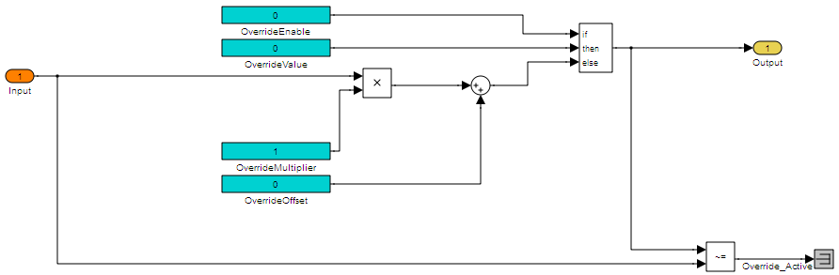
Figure 4 Override in Simulink

Main layout
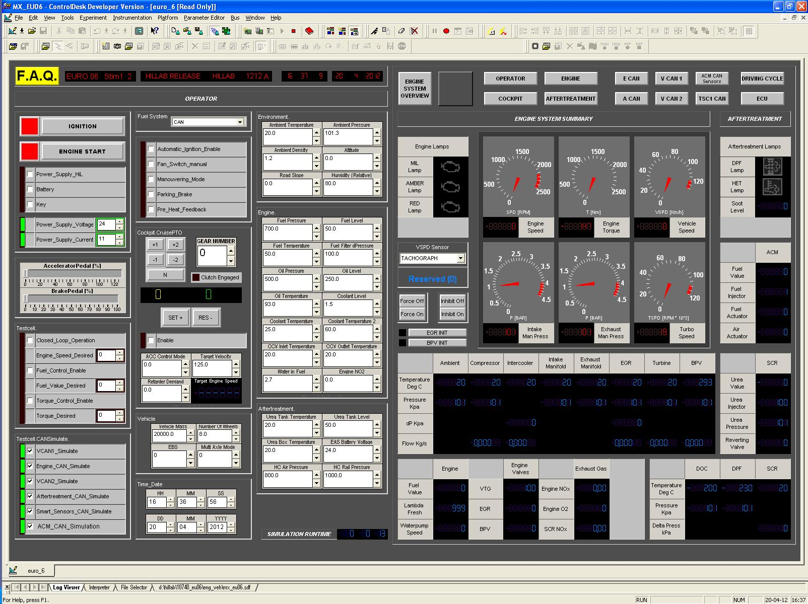
Figure 5 Main GUI layout, it is a summary of the most relevant signals and contains links to other GUI layouts.

Operator
The operator layout is a combination of controls for
- Test cell operator
- Environment settings
- Electrical settings
- Engine constants
- Vehicle configuration
- DM13
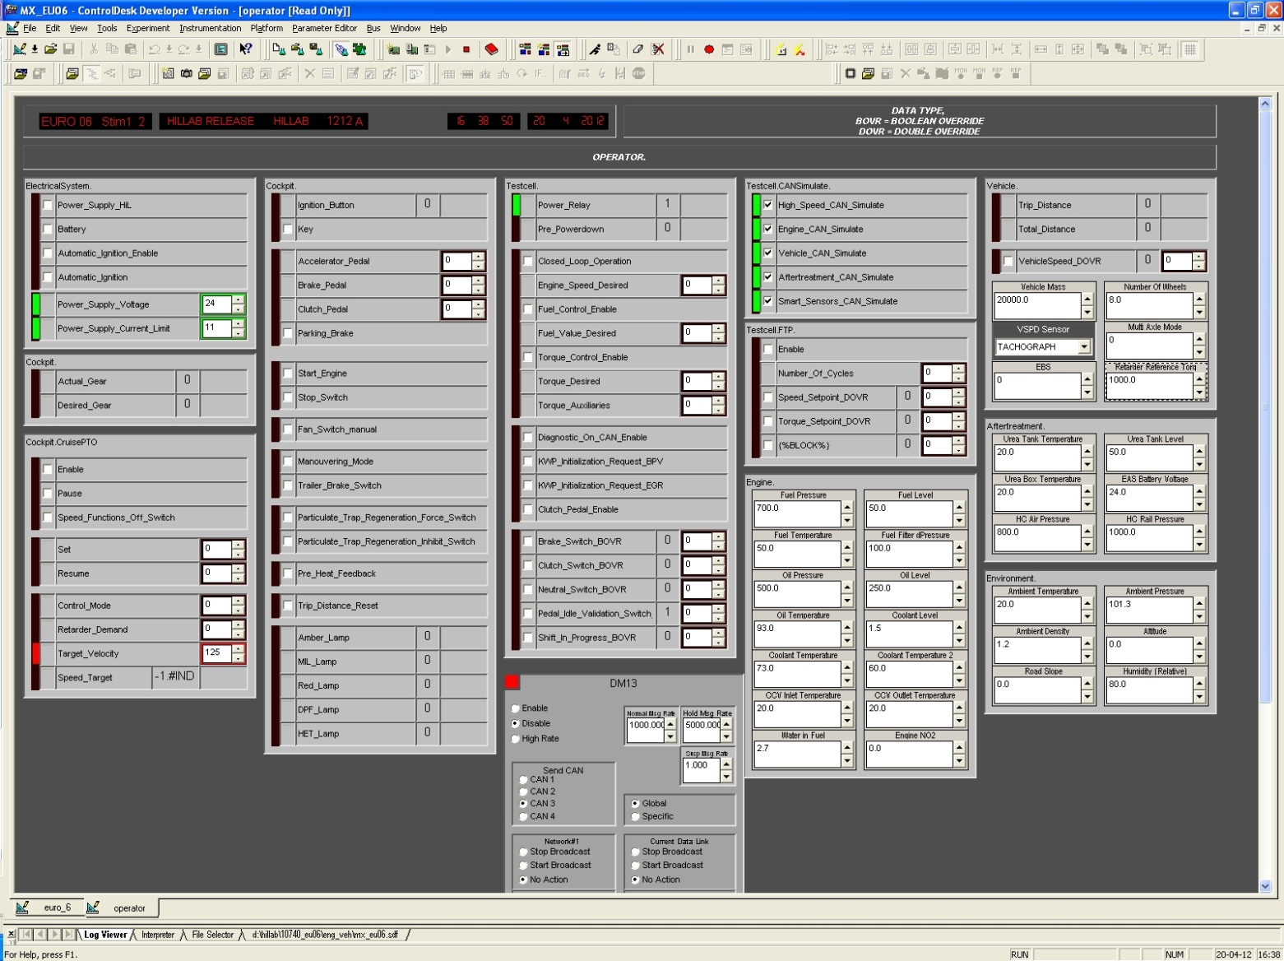

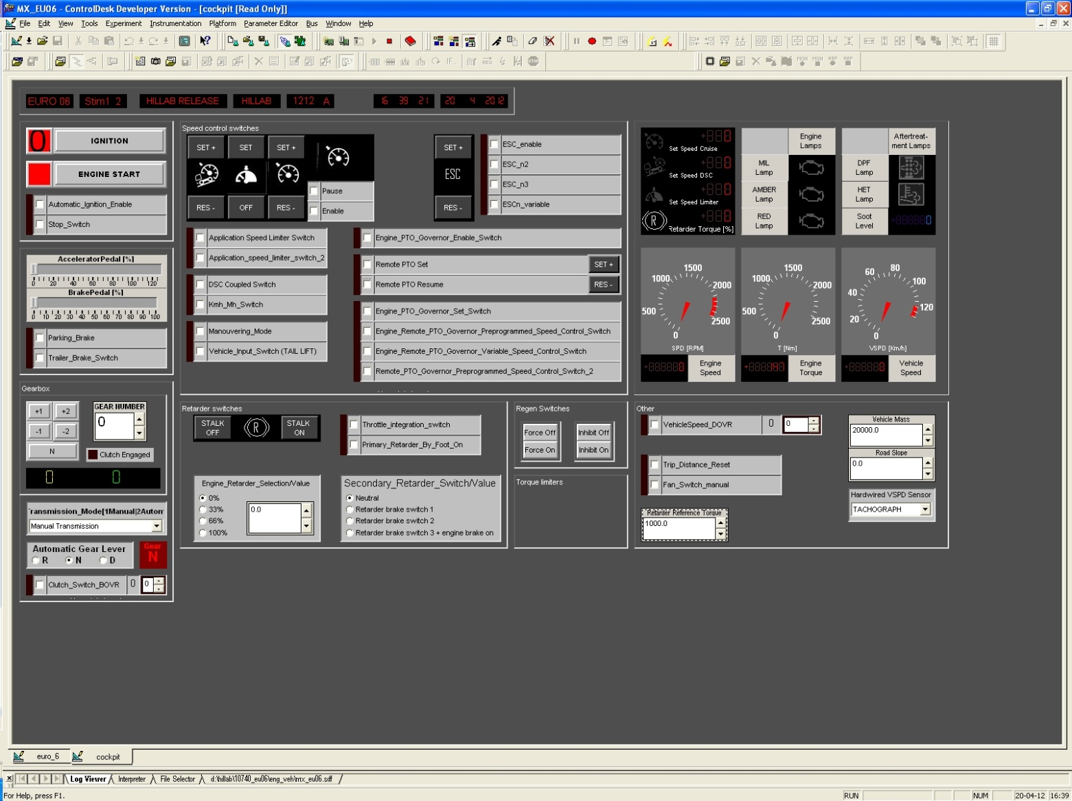
Cockpit
Figure 6 Cockpit Gui layout

The cockpit layout contains a superset of the controls and indicators a driver has at his disposal. Only the engine torque gauge is not present in a real cab. In reality a driver would have to estimate how much power the engine is delivering.

CAN Layouts
All CAN signals that go to the Engine ECU (PCI) and are sent by the Engine ECU can be manipulated or read. All content of all messages with a length of 8 bytes or shorter, are available via ControlDesk layouts. There is a layout for every CAN bus. TSC1 messages have a separate Layout.
- ECAN - Engine CAN
- ACAN
- VCAN1
- VCAN2
In general, these CAN layouts can be divided in a Rx and Tx part. The left part is dedicated to signals inside CAN messages being sent to the ECU. So, this is the Rx part because the ECU will receive them. All CAN signals in this plane are determined by the simulation. Some of them are suitable constants, others are continuously calculated by the models in the simulation. With overrides, testers have complete control over the CAN inputs of the ECU.
On the Tx side, the ECU determines the content of the messages. The ControlDesk layout only visualizes their status.
Figure 7 Visualisation of Tx CAN message

Figure 8 Example of CAN Override

Engine CAN layout
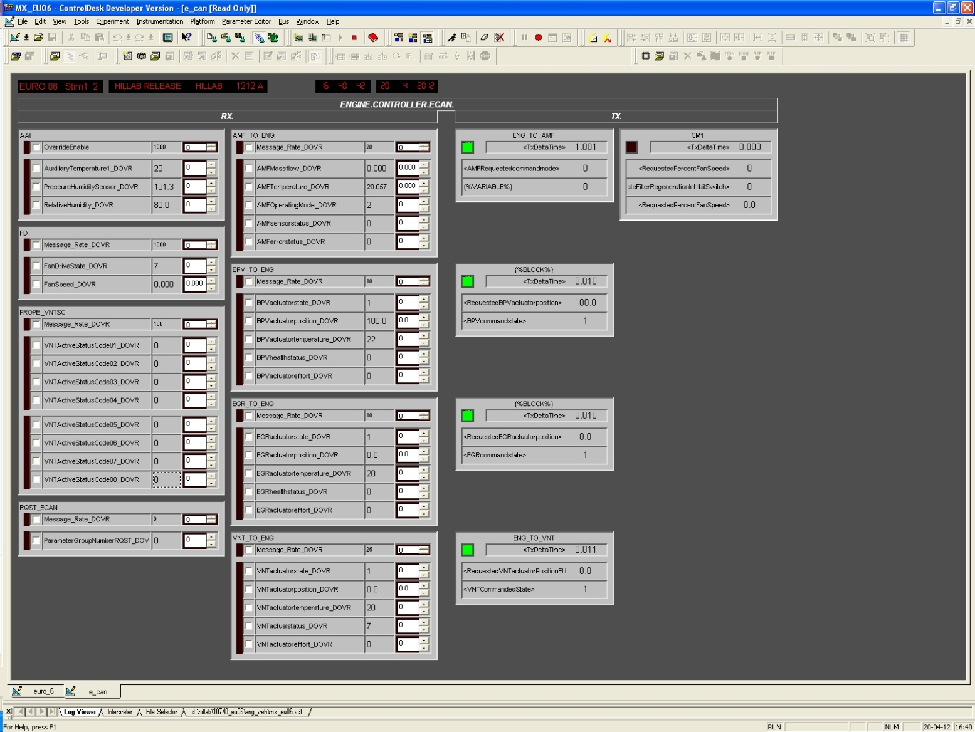
Figure 9 Engine CAN Gui Layout

After treatment CAN layout
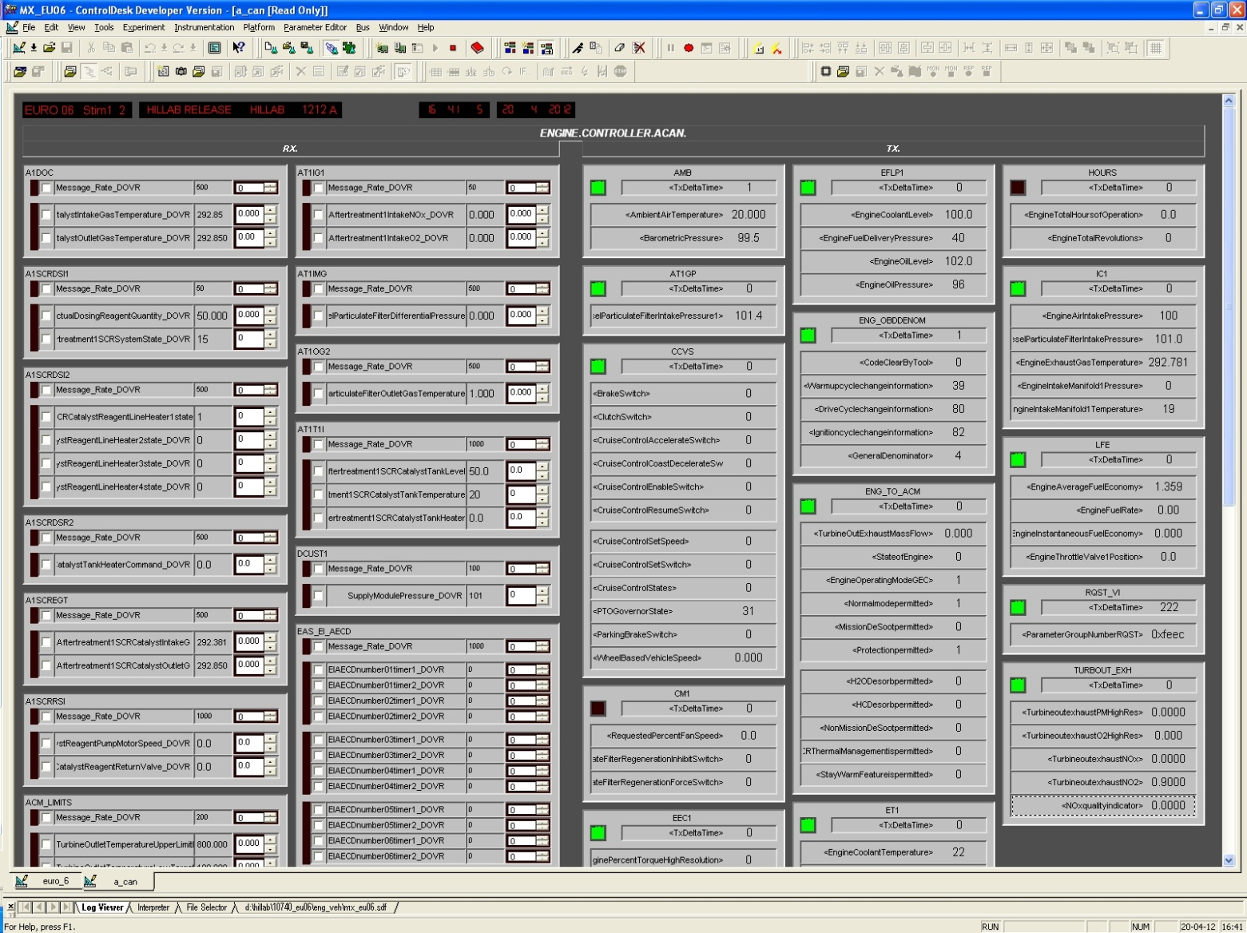

Vehicle CAN 1

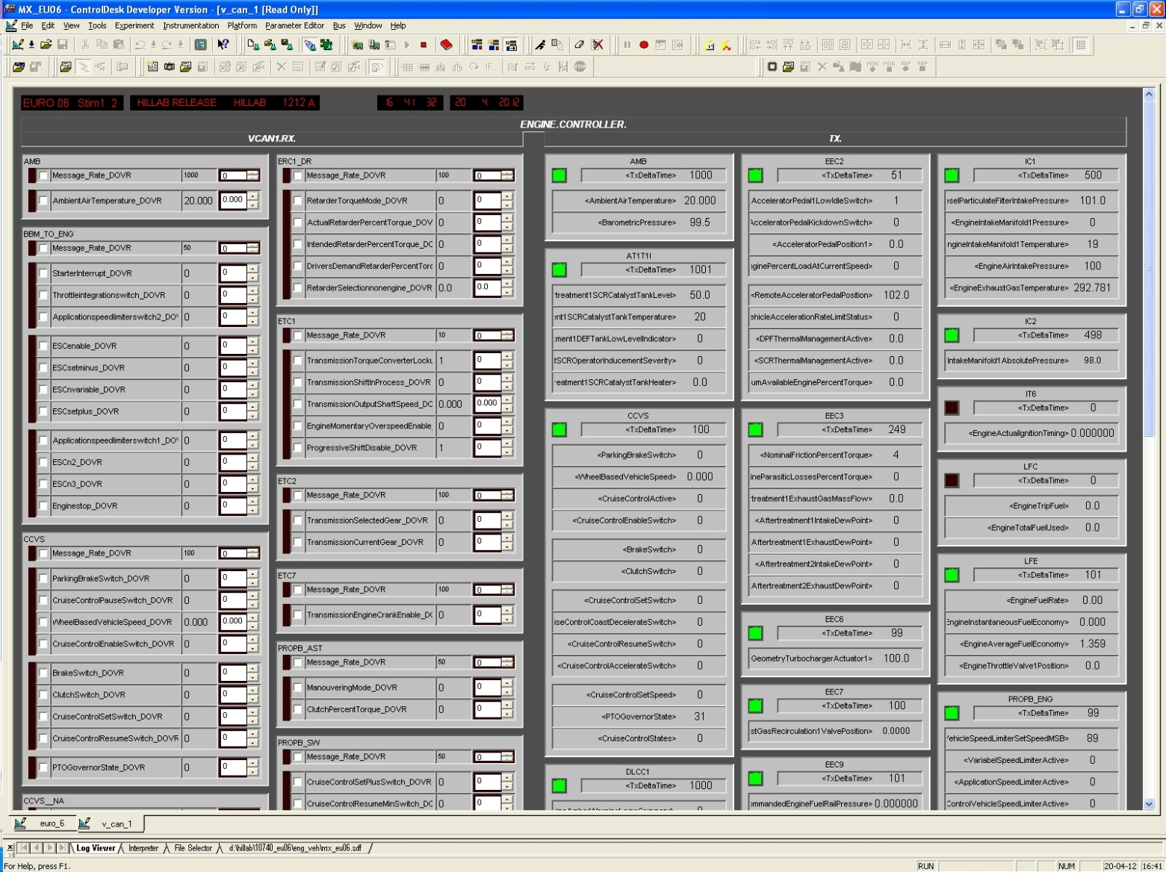
This picture is not complete, it is to give an impression of how the layout of VCAN1 looks like.

Vehicle CAN2

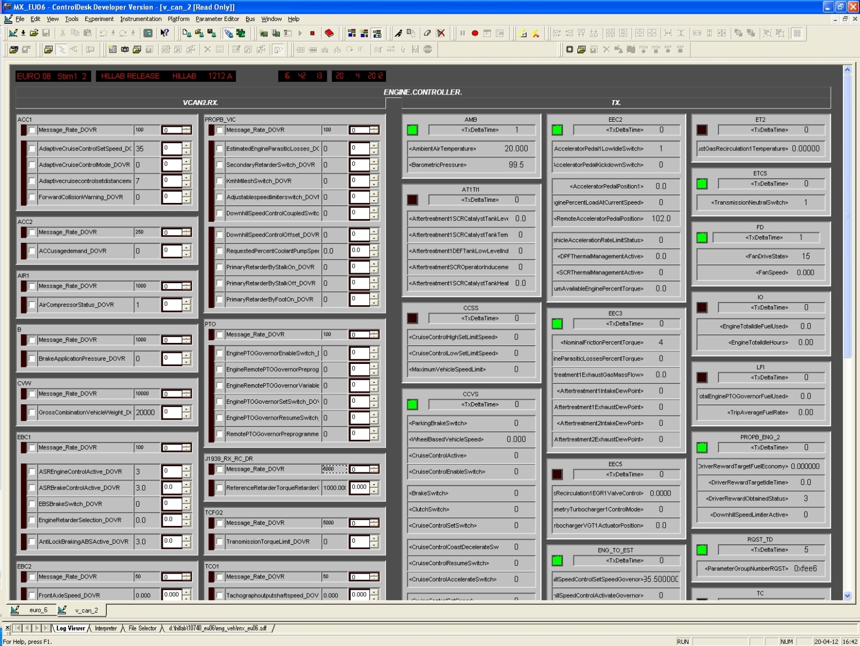

TSC1 messages
All TSC1 messages are gathered in 1 layout. Although they exist on all CAN busses, they are only displayed here.
The TSC1 messages are a bit special, since a checksum is part of the message content. It is calculated from message id and other message contents. When a tester is overriding one of the message contents, of course the checksum will be calculated with using that value.
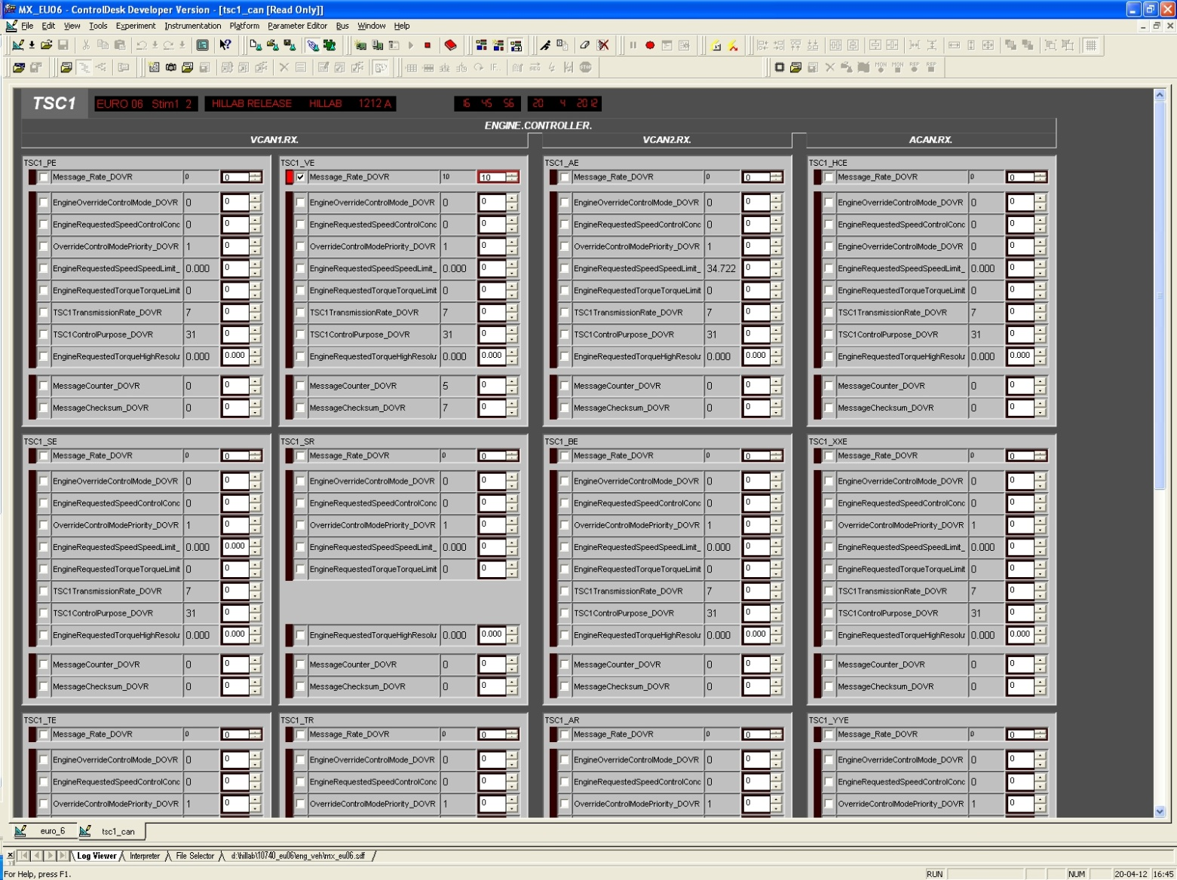

Running Man
The running man is actually the button in ControlDesk to run a python script. At the DAF EMS HIL system, running the ‘StartKeywordsInControlDesk.py’ script, will enable usage of DAFTA keywords during manual testing.

Figure 10 Running man icon in ControlDesk
These keywords give the tester more possibilities for overrides and makes it possible to use functionality for which no layout can be created. These extra functionality comprises:
- Multiplication for overrides
- Offsets for overrides
- KWP commands
- High level commands for
  - Driver
  - Mechanic

Manual testing with the use of DAFTA keywords and short scripts gives such a wide scope of extra capabilities, that the next chapter is dedicated to this functionality.

DAFTA keywords for Manual Testing
Manual testing with the use of DAFTA keywords and short scripts gives such a wide scope of extra capabilities, that this chapter is dedicated to this functionality.
The possibilities for manual testing are increased dramatically, when DAFTA keywords are used in conjunction with regular manual testing. The keywords where introduced into the manual test environment to make functionality available to the tester that cannot always be accessed via the regular ControlDesk layout controls.
The extra functionality comprises:
- Multiplication for overrides
- Offsets for overrides
- KWP commands
- High level commands for
  - Driver
  - Mechanic

…and Test automation
The keywords that can be used for manual testing are the same as those used for test automation with DAFTA.

Work with DAFTA keywords
To start working with DAFTA keywords in manual testing, the user has to perform a few steps. The method described in 3.6 Running Man can be used when only a few things have to be tested. When using keywords inside ControlDesk, the layout freezes until the execution of the keyword is finished.
Preferably, use the following method:
- In PyScripter, open ‘D:\HILLab\MESST\ StartKeywordsInControlDesk.py
- Press the play button, to execute the script
- In the interpreter, the initialization can be witnessed, observing the trace messages
- Keywords can be entered in the interpreter
The PyScripter interpreter offers autocomplete for all keywords. This means that you do not have to look up all the possibilities or have to know them by heart. On top of that, using the autocomplete reduces typos.

Live
This keyword is designed to represent the live ecu. Its members are the APVs, MPVs and measurements that live inside the ECU. Live gets the values of the A2L items from ATI Vision.

KWP
This object offers KWP services and interpretation of ECU replies. To use the KWP object, knowledge of KWP is required. To send a command is very easy and in any cases the output in the interpreter window of ControlDesk suffices, because often the ECU has to do something. Nevertheless, to interpret the answer of the ECU, knowledge about the possible answers is required. In Figure 11 an example is shown about sending a simple command.
Figure 11 Flow chart of dealing with a simple KWP command

Information that is often asked from the ECU are DTC’s. If a service is called, where a positive response will include a list of DTC’s, the Kwp object stores those DTCs in Kwp.DtcList. An example of such a command is Kwp.readDiagnosticTroubleCodeByStatus. Figure 12 shows what steps are taken by the Kwp object and the user while using this command.

Figure 12 Flow chart of using a Kwp function that requests DTC's from the ECU. On the right, the UML description of the resulting DtcList and the DTC objects inside.
Similar to the DTC requesting services, also for FreezeFrame requesting functions, the FreezeFrame data is stored in Kwp.FrzFrData. However, Kwp.FrzFrData is a raw list of byte values. Finally Figure 13 shows the UML representation of the KWP object as present in DAFTA and ‘Running man’.
Figure 13 UML overview of Kwp object

Mechanic
The object is intended to perform common tasks of mechanics like diagnostics.

Driver
This object takes care of regular driver tasks. For example, with one keyword, the Driver can be commanded to take the vehicle to a certain speed.

XCP
This object is developed for XCP Stim to an ECU. In normal HILLab releases, the XCP object is absent. XCP can only be used when an simulation model is used, that has XCP enabled. It can only be used at HIL 1 & 2. Such a model can be built on request.
The optional XCP module is easy to use. Some steps have to be taken to ensure the right results.

Usage
The XCP communication layer runs in the simulation model and needs to work with A2L data, therefore the XCP object has to be connected to the ‘Live’ object. That object provides the A2L information of software labels to the XCP component.
At the same time, up to 7 different ECU labels can be overwritten by the XCP interface. The system keeps a list of items that is stimulated. This list works similar to a stack. If the stack is full and another item needs to be overwritten, the stack has to be emptied at once. Then, new items can be added to the stack. To ensure correct functioning of test scripts, the test developer has to keep track of the number of items that are stimulated at the same time. These steps are illustrated in Figure 14 Flow diagram for use of XCP in DAFTA.

Limitation
At the same time up to 7 different ECU labels can be overwritten by the XCP interface. It is a limitation caused by the XCP implementation in the simulation model.

Figure 14 Flow diagram for use of XCP in DAFTA

ATI Vision
In general, ATI Vision is a calibration tool. It is used to view and modify software parameters (characteristics) and view software variables (measurements) both online. It can also be used to view and modify characteristics offline.

Basics
The basic principles of ATI Vision are explained in the user reference guide of ATI Vision. Recommended chapters to read:
- This
- That

Diagnostics

CAN & J1939

Flashing

XCP needs the following A2L data : address, coefficients, data type

